Solution Architecture – Script Control ACL
You can add this under Project Design Phase → Solution Architecture.
Architecture Diagram
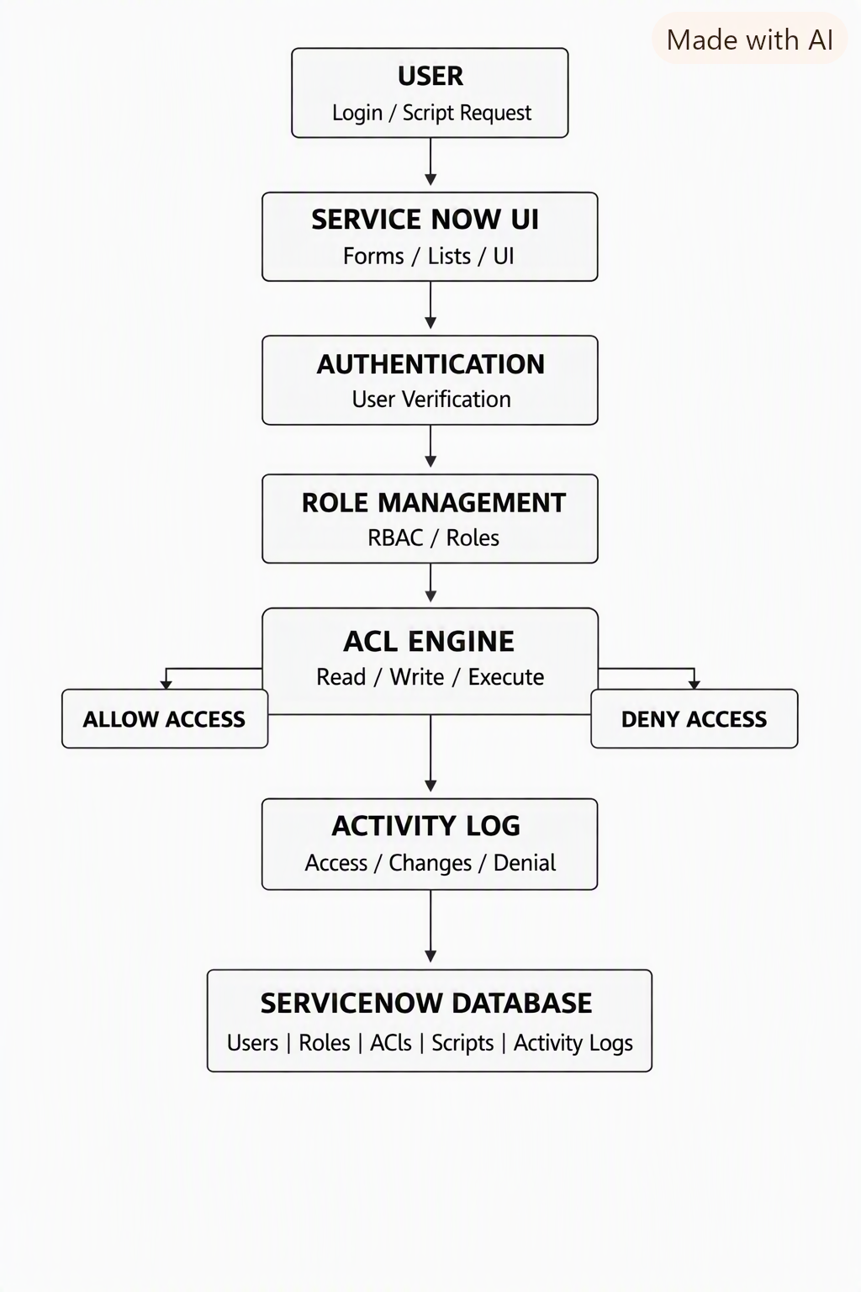
Architecture Components
- User Interface – Users interact with the system through ServiceNow Forms, Lists, and UI.
- Authentication Layer – Verifies the user's identity.
- Role Management – Determines the user's assigned role using RBAC.
- ACL Engine – Checks whether the user has Read, Write, or Execute permission.
- Access Decision – Allows or denies the requested operation.
- Activity Log – Records access attempts and important actions.
- ServiceNow Database – Stores users, roles, ACL rules, scripts, and activity logs.
Architecture Flow
User → ServiceNow UI → Authentication → Role Validation → ACL Check → Allow/Deny → Activity Log → Database
Technology: ServiceNow + JavaScript + ACL + RBAC + ServiceNow Database.

